### Existing research on EEG data

*You might have to be logged in through the PSU library portal to access some of the IEEE datasets.*

**Basic introduction to EEGs and brainwaves**

<https://www.medicine.mcgill.ca/physio/vlab/biomed_signals/eeg_n.htm>

**Sleep Stages and Scoring Technique**

<http://www.fmed.edu.uy/sites/www.labsueno.fmed.edu.uy/files/9.Diagnostico-polisomnogr%C3%A1fico.pdf>

**Normal Sleep EEG**

<https://emedicine.medscape.com/article/1140322-overview#a1>

**Visualization of Whole-Night Sleep EEG From 2-Channel Mobile Recording Device Reveals Distinct Deep Sleep Stages with Differential Electrodermal Activity**

<https://www.frontiersin.org/articles/10.3389/fnhum.2016.00605/full>

**Analysis of Multichannel EEG Patterns During Human Sleep: A Novel Approach**

<https://www.frontiersin.org/articles/10.3389/fnhum.2018.00121/full>

**Electroencephalography: An Introductory Text and Atlas of Normal and Abnormal Findings in Adults, Children, and Infants**

<https://www.ncbi.nlm.nih.gov/books/NBK390354/pdf/Bookshelf_NBK390354.pdf>

**Comparison of Smoothing Filters in Analysis of EEG Data for the Medical Diagnostics Purposes**

<https://www.ncbi.nlm.nih.gov/pmc/articles/PMC7038754/>

**EEG-Datasets**

<https://github.com/meagmohit/EEG-Datasets>

**DATASETS FOR "GRAPH ANALYSIS OF SINGLE-CHANNEL SLEEP STAGE EEG WITH DIFFERENT ELECTRODE PLACEMENTS"**

<https://ieee-dataport.org/documents/datasets-graph-analysis-single-channel-sleep-stage-eeg-different-electrode-placements>

**ACTIVITIES OF DAILY LIVINGS USING A PORTABLE EEG HEADSET**

<https://ieee-dataport.org/open-access/activities-daily-livings-using-portable-eeg-headset>

**DIY EEG (and ECG) Circuit**

<https://www.instructables.com/DIY-EEG-and-ECG-Circuit/>

**Final Project: DIY EEG EEG: Cheap and Small Fall 2015**

<http://fab.cba.mit.edu/classes/863.15/section.Harvard/people/Ricker/htm/Final_Project.html>

She links to this:

**Homebrew Do-it-yourself EEG, EKG, and EMG**

<https://sites.google.com/site/chipstein/home-page>

*(good idea… but some broken links)*

**Make an EEG Beanie That Reads Your Mind**

<https://makezine.com/projects/mind-reading-beanie/>

**The Introductory Guide to EEG**

**(Electroencephalography)**

<https://www.emotiv.com/eeg-guide/>

*(interesting idea using the ear to hold electrodes)*

**Unobtrusive ambulatory EEG using a smartphone and flexible printed electrodes around the ear**

<https://www.nature.com/articles/srep16743>

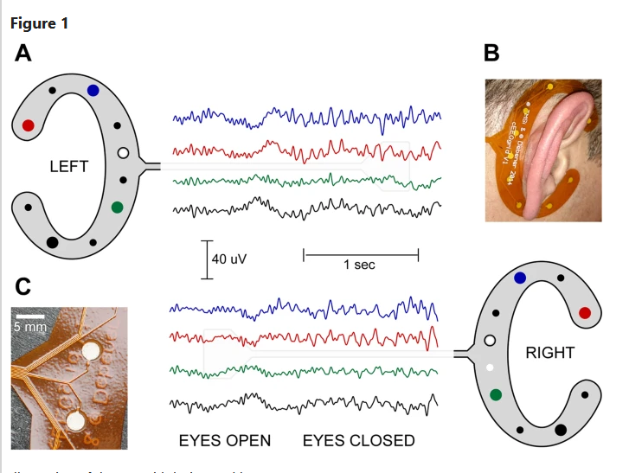

*(I like this one… But there are broken links. Maybe it's a dead project)*

**Welcome to the OpenEEG project**

<http://openeeg.sourceforge.net/doc/index.html>

**EEG probe electrode amplifier design**

<https://www.researchgate.net/publication/50398093_Portable_cost-effective_EEG_data_acquisition_system>

<https://www.sleepfoundation.org/stages-of-sleep>

**TinySleepNet - open source deep learning model for sleep scoring (python)**

<https://github.com/akaraspt/tinysleepnet>

<https://ieeexplore.ieee.org/document/9176741>

**Using Two EEG electrodes on forehead**

<https://pubmed.ncbi.nlm.nih.gov/24313630/>

**EEG Montage configurations (not entirely applicable but useful knowledge)**<https://www.learningeeg.com/montages-and-technical-components>

**AASM Recommendations for EEG Electrode Placement in Polysomnography: Impact on Sleep and Cortical Arousal Scoring**<https://academic.oup.com/sleep/article/34/1/73/2433800?login=false>

**Main features of the EEG amplifier explained**

<https://www.bitbrain.com/blog/eeg-amplifier>